Company Overview

Ocean First Trading is a professional trading and supply company dedicated to serving industrial, commercial, and marine sectors. Through a reliable network of manufacturers and suppliers, we provide a comprehensive range of high-quality products, competitive pricing and equipment tailored to our clients’ requirements with efficiency, quality.
Scope of Activities & Capabilities

Our company is capable of supplying and providing the following products and services:
* Ship Chandler Services
* Deck Store Supply
* Engine Store Supply
* Cabin Store Supply
* Safety Store Supply
* Marine Lubricants Supply
* Provisions and Bonded Stores
* Medical and Pharmaceutical Supplies
* Navigation and Communication Equipment
* Cleaning and Hygiene Supplies
* Technical and General Marine Consumables
* Logistics and Delivery Services

Deck Stores



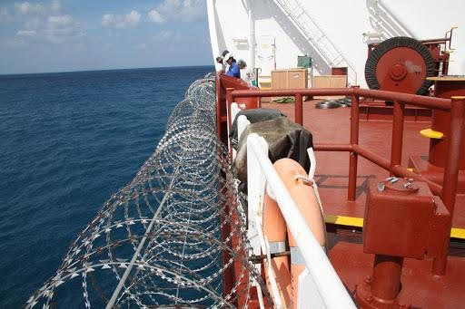

Anti Pira Equipment Fender

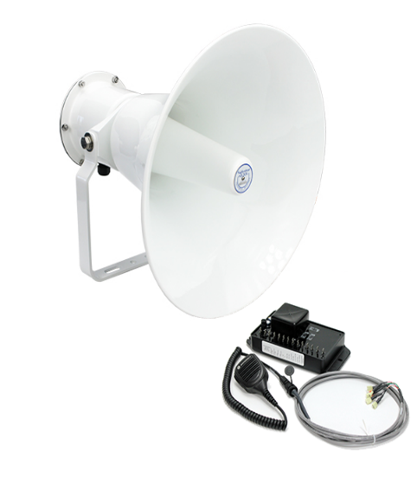

Air Horns Lashing Equipment

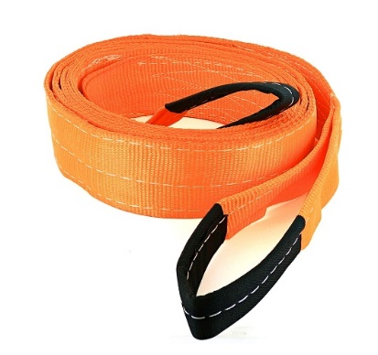

Ladder Rigging Equipment

Cabin Stores



Provision



Tools & Hand Tools



Ropes & Lifting Tackles



Electrical Stores



Mission

To provide reliable and cost-effective supply solutions for general, industrial, and marine sectors while maintaining the highest standards of quality, efficiency, and customer satisfaction.

Core Values

* Integrity
* Quality Commitment
* Accountability
* Customer Focus
* Timely Delivery
* Continuous Improvement

Professional Slogan

* Reliable Supply, Trusted Partnership
* Delivering Quality, Building Trust
* Your Trusted Source for Marine & Industrial Supply

Commitments
We are committed to providing quality products, competitive pricing, prompt delivery, and reliable customer service as well as transparency and efficiency to ensure complete customer satisfaction. Our flexible business model allows us to act both as a direct supplier and a procurement intermediary, depending on project requirements, ensuring optimal solutions for our clients.

Company name

Ocean First Trading Co.

Adress : Iran, Tehran, Above Valiasr Square, Ghayoumi St., Unit 3, No.2
P.O Box: 1594716114
Phone : +98 021 9200 6816
Email : info@oceanft.org
Website : www.oceanft.org

